MODULE 3

Introduction to BASH Shell Scripting

- Write a simple Bash shell script to display the message "Welcome to Bash learning" and "***************" on separate lines.
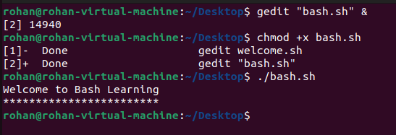

Bash Variables

1) Write a simple Bash program to get the following system variables:
a. pwd
b. logname
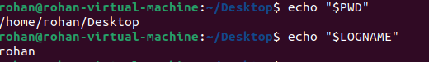

2) Write a simple Bash program:
a. To ask username from user
b. Exit the program, if user does not enter anything within 10 seconds

Hint: read -t 10 -p

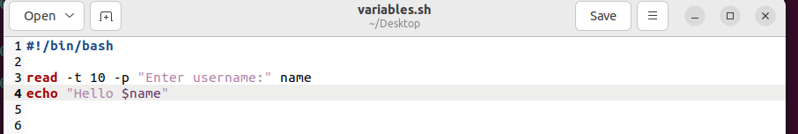
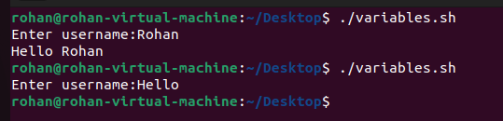

Command Line arguments and Quoting

1) Write a bash program for addition using command line arguments.
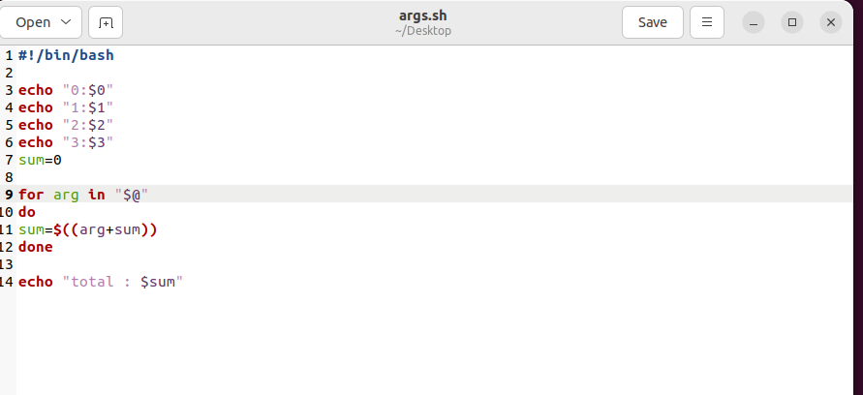

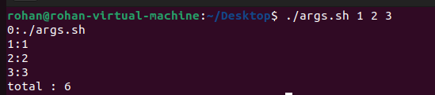

Globbing and Export statement

1) Write a Bash script to do all operations discussed under Globbing
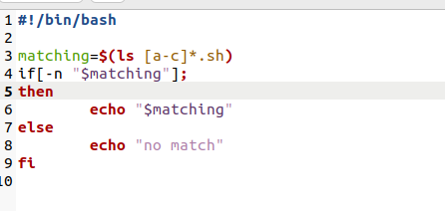

Array Operations in BASH

1) Declare an Array names of length 7 and find
a. The total number of elements
b. Print all the elements
c. Print the 5th element

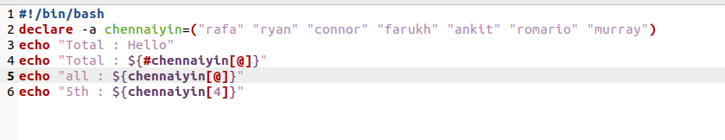
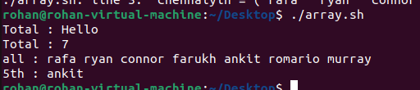

More on Arrays

1) Declare an Array names2 of length 7 and perform following operations-
a. Extract three elements starting from index two.
b. Replace third element with 'Debian' and display.
c. Append any new name at the end of Array.

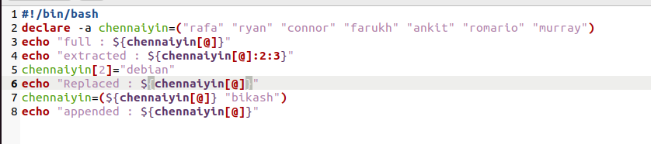
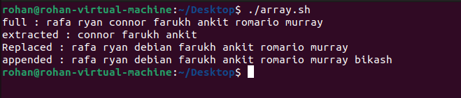

Conditional execution

1) Write a script which will take your name as an input.
2) It should check this name with your system's username.
3) If the username matches, it should greet you by displaying "Hello".
4) Else, it should display "Try again"

HINT: Your system's username is stored in a variable $USER

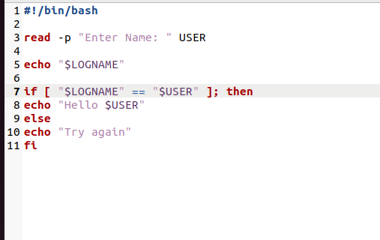
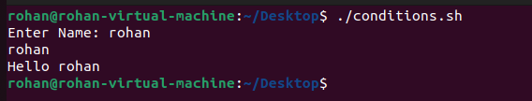

Nested and multilevel if elsif statements

1) Write a program to output different messages when number is:
a. Greater than 3
b. Lesser than 3
c. Or equal to 3
d. Or when the user input is empty

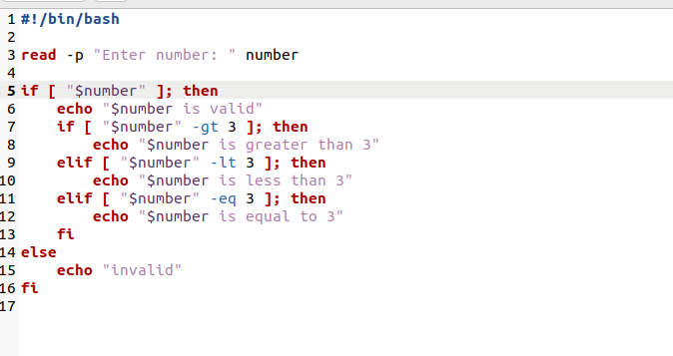

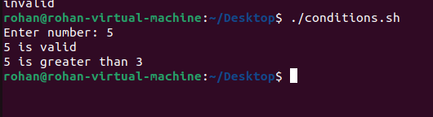

Logical Operators

1) Check whether the file exists and is executable using logical operators.
Hint:man test

